# JS Advanced Final Exam

# Problem 1. Travel Agency

**Environment Specifics**

Please, be aware that every JS environment may **behave differently** when executing code. Certain things that work in the browser are not supported in **Node.js**, which is the environment used by **Judge**.

The following actions are **NOT** supported:

* **.forEach()** with **NodeList** (returned by **querySelector()** and **querySelectorAll()**)
* **.forEach()** with **HTMLCollection** (returned by **getElementsByClassName()** and **element.children**)
* Using the **spread-operator** (**...**) to convert a **NodeList** into an array
* **append()** in Judge (use only **appendChild()**)

If you want to perform these operations, you may use **Array.from()** to first convert the collection into an array.

**Use the provided skeleton to solve this problem.**

**Write the missing functionality** of this user interface. The functionality is divided in the following steps:

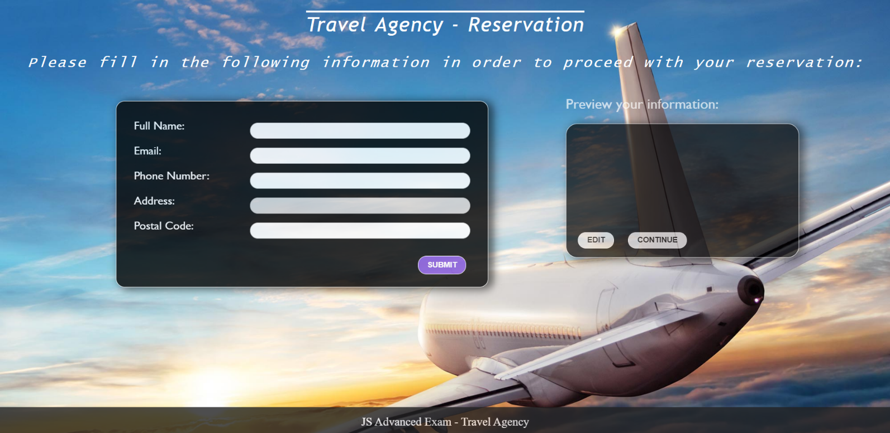

## ****Getting the user’s personal information****

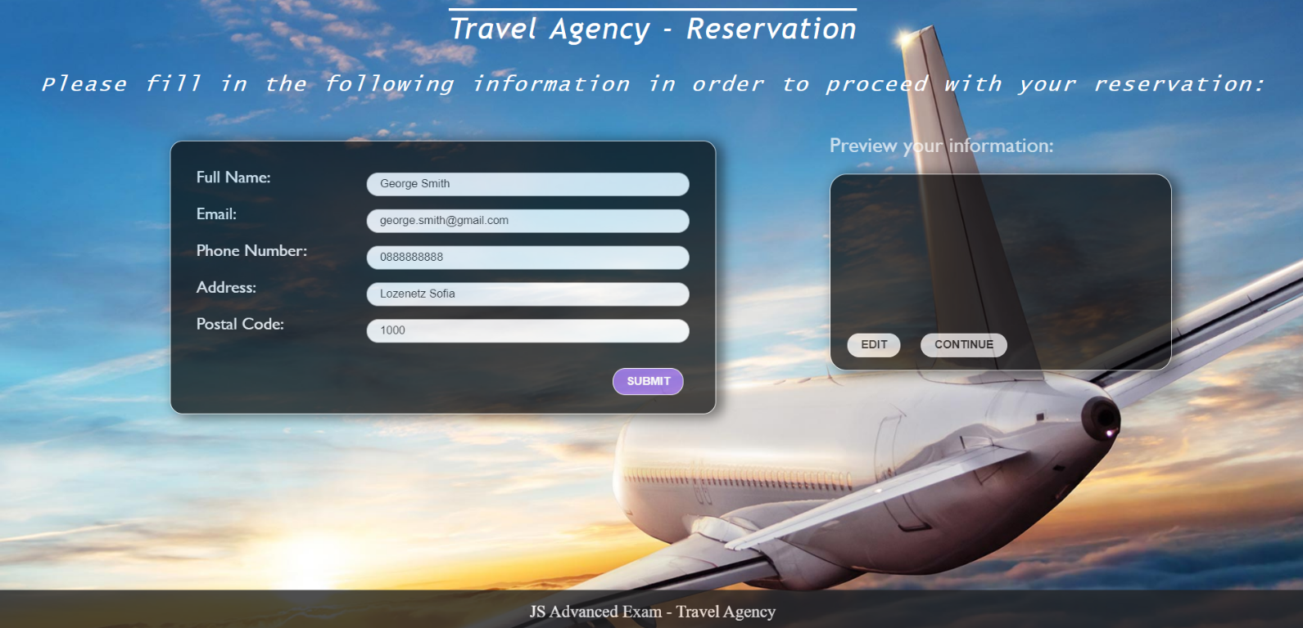

* On clicking the “Submit” button the information from the input fields is listed in the “preview” section. For each input field a **list item** is **added** to the “infoPreview” unordered list.
* The text format and order for each list item should be the same as on the second picture below.
* When the button is clicked, the input fields must be cleared and the “Submit” button must be **disabled**. At the same time the “Edit” button and the “Continue” button must be **enabled**.
* One can only submit information if the **“Full Name”** and **“Email**” input fields are **not empty**.

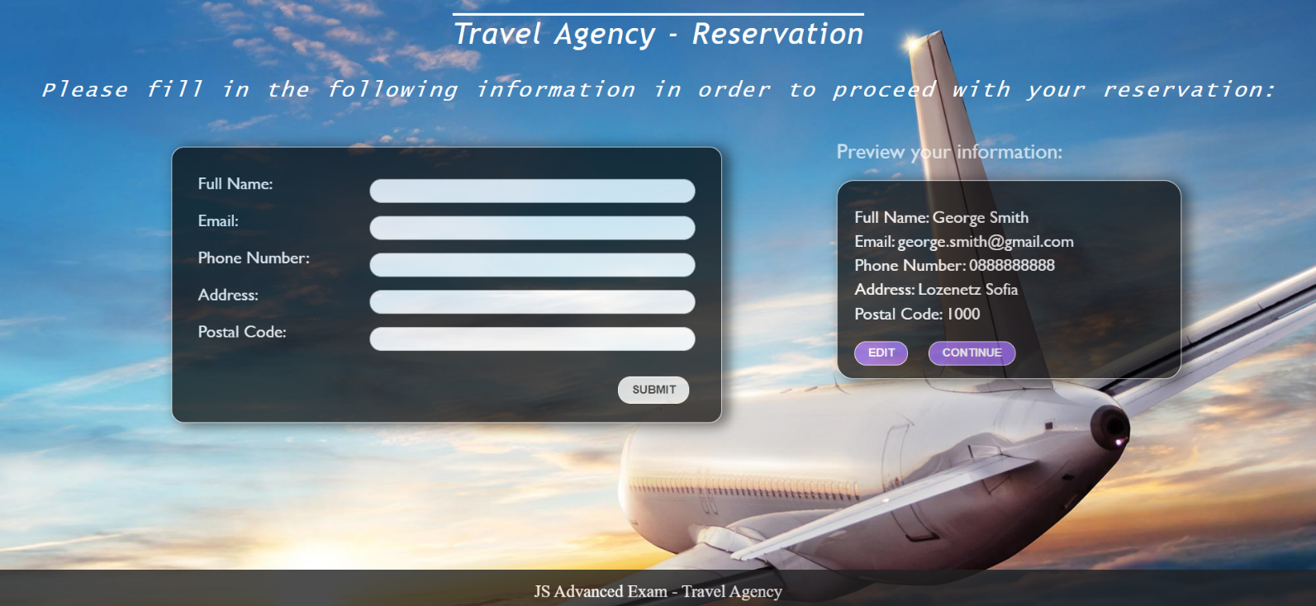

## ****Previewing the user’s personal information****

**This is an example for the preview section:**

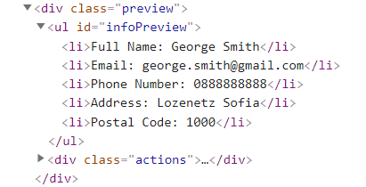

**The functionality here is the following:**

* **When the “**Edit” **button is clicked, all of the personal information of the user is loaded in the input fields from step I and both the** “Edit” **and** “Continue” **buttons are disabled while the** “Submit” **button is enabled again.**

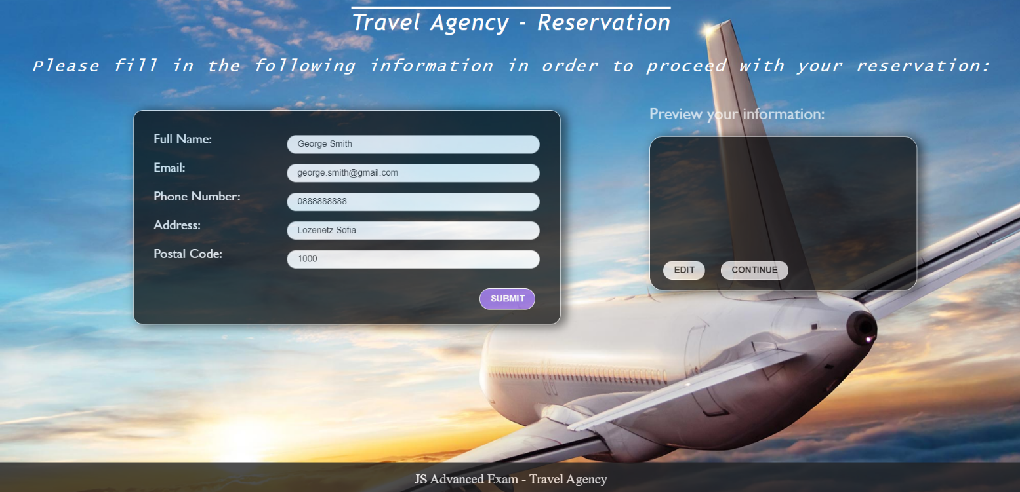

* **The list items must be removed from the** “infoPreview”**.**

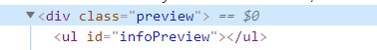

* **When the** “Continue” **button is clicked,** **the reservation is completed. For you, this means removing everything inside of the** “block” **<div> and adding there only a <h3> tag: "Thank you for your reservation!" message:**



**This is everything your webpage must contain at this step:**

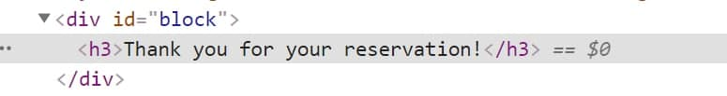

# Submission

Submit only yours **solution()** function.

# 100/100

function solution() {

    let inputForm = document.querySelector('#form');

    let fullNameInput = inputForm.querySelector('#fname');

    let emailInput = inputForm.querySelector('#email');

    let phoneNumberInput = inputForm.querySelector('#phone');

    let addressInput = inputForm.querySelector('#address');

    let postalCodeInput = inputForm.querySelector('#code');

    let submitButton = inputForm.querySelector('#submitBTN');

    let infoPreviewList = document.querySelector('#infoPreview');

    let editButton = document.querySelector('#editBTN');

    let continueButton = document.querySelector('#continueBTN');

    let blockDiv = document.querySelector('#block');

    let inputObject = {

      fullName: '',

      email: '',

      phoneNumber: 0,

      address: '',

      postalCode: '',

    };

    submitButton.addEventListener('click', (e) => {

      if (fullNameInput.value === '' || emailInput.value === '') {

        return;

      }

      fillObject();

      createPreview();

      clearInputFields();

      enablePreviewButtons();

    });

    function createPreview() {

      let fullNameListElement = document.createElement('li');

      let emailListElement = document.createElement('li');

      let phoneNumberListElement = document.createElement('li');

      let addressListElement = document.createElement('li');

      let postalCodeListElement = document.createElement('li');

      fullNameListElement.textContent = `Full Name: ${fullNameInput.value}`;

      emailListElement.textContent = `Email: ${emailInput.value}`;

      phoneNumberListElement.textContent = `Phone Number: ${phoneNumberInput.value}`;

      addressListElement.textContent = `Address: ${addressInput.value}`;

      postalCodeListElement.textContent = `Postal Code: ${postalCodeInput.value}`;

      infoPreviewList.appendChild(fullNameListElement);

      infoPreviewList.appendChild(emailListElement);

      infoPreviewList.appendChild(phoneNumberListElement);

      infoPreviewList.appendChild(addressListElement);

      infoPreviewList.appendChild(postalCodeListElement);

    }

    function fillObject() {

      inputObject.fullName = fullNameInput.value;

      inputObject.email = emailInput.value;

      inputObject.phoneNumber = phoneNumberInput.value;

      inputObject.address = addressInput.value;

      inputObject.postalCode = postalCodeInput.value;

    }

    function clearInputFields() {

      fullNameInput.value = '';

      emailInput.value = '';

      phoneNumberInput.value = '';

      addressInput.value = '';

      postalCodeInput.value = '';

    }

    function enablePreviewButtons() {

      submitButton.disabled = true;

      editButton.disabled = false;

      continueButton.disabled = false;

      editButton.addEventListener('click', edit);

      continueButton.addEventListener('click', continueToTheEnd);

    }

    function disablePreviewButtons() {

      editButton.disabled = true;

      continueButton.disabled = true;

    }

    function edit() {

      fullNameInput.value = inputObject.fullName;

      emailInput.value = inputObject.email;

      phoneNumberInput.value = inputObject.phoneNumber;

      addressInput.value = inputObject.address;

      postalCodeInput.value = inputObject.postalCode;

      disablePreviewButtons();

      submitButton.disabled = false;

      clearPreviewList();

    }

    function continueToTheEnd() {

      let h3 = document.createElement('h3');

      h3.textContent = "Thank you for your reservation!";

      removeAllChildNodes(blockDiv);

      blockDiv.appendChild(h3);

    }

    function clearPreviewList() {

      removeAllChildNodes(infoPreviewList);

    }

    function removeAllChildNodes(parent) {

      while (parent.firstChild) {

        parent.removeChild(parent.firstChild);

      }

    }

  }